Feeback 17: Remaining of feedback 14, 15 and 16 – 25/11/2024

Education and Certifications
In Other certifications: Choose file and upload file doesn't work when you add other certifications

Mandatory Training and Education :
Completed Mandatory Training: Remove these 3 fields as they will be asked later each time.
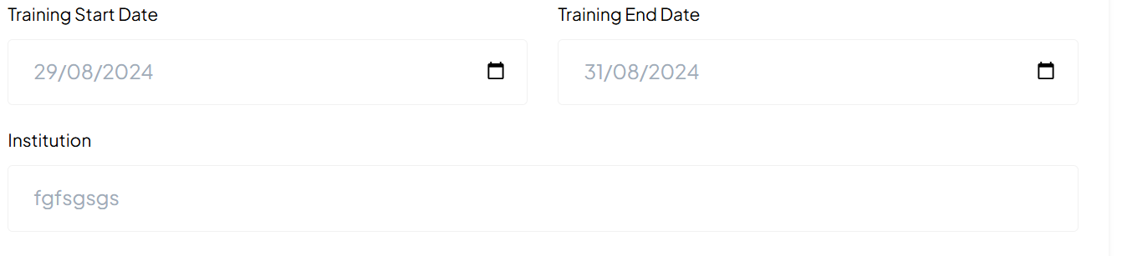
Just after Completed Mandatory Training you will have this sentence:
Please add required courses or certifications completed for compliance or safety

Only green data have been added, Please complete the missing data:
IF Clinical Skills and Core Competencies Selected, then:
Aggressive Behaviour Management
Aseptic Technique
Blood Transfusion Protocols
BloodSafe eLearning
Breastfeeding Promotion
Breastfeeding Support and Lactation Management
Certificate III Health Services Assistance (Nursing Acute Care assistance)
Certificate III in Aged Care
Chemotherapy Competency
Emergency and Trauma Care
Infection Prevention and Control
Medication Administration
Pain Management
Patient Assessment Skills
Perioperative Nursing Skills
Postpartum Hemorrhage Management
Venipuncture and IV Cannulation
Vital Signs Monitoring
Wound Care Management

IF Midwifery-Specific Training Selected, then:
Caesarean Section Assistance
Family Planning and Contraceptive Counseling
Fetal Monitoring
Gestational Diabetes Management
Labor and Delivery Management
Management of Obstetric Emergencies
Management of Preeclampsia and Eclampsia
Maternal and Child Health
Newborn Care and Resuscitation
Normal Birth and Vaginal Delivery
Perineal Suturing
Postnatal Care
Water Birth Facilitation

IF Leadership and Professional Development Selected, then:
Clinical Auditing
Clinical Supervision and Mentorship
Conflict Resolution and Mediation
Cultural Competency and Diversity in Care
Ethical Decision Making in Nursing
Health Informatics and EHR (Electronic Health Records)
Legal Issues in Healthcare
Nurse Leadership and Management
Nursing Policy and Advocacy
Professional Writing and Documentation Skills
Quality Improvement and Patient Safety
Research and Evidence-Based Practice
Teaching and Preceptorship Skills
Team Communication and Collaboration
Time Management and Delegation

IF Technology and Innovation in Healthcare Selected, then:
Advanced Wound Care Technologies
Data Analytics in Nursing Care
Electronic Fetal Monitoring
Mobile Health Apps for Nursing Care
Point-of-Care Ultrasound (POCUS)
Robotic-Assisted Surgery Nursing
Simulation-Based Clinical Training
Telehealth and Virtual Care Delivery
Use of Wearable Health Technology

IF Wellness and Self-Care Selected, then:
Compassion Fatigue and Burnout Prevention
Emotional Intelligence and Resilience Training
Ergonomics and Safe Patient Handling
Healthy Lifestyle Promotion for Nurses
Mindfulness and Mental Health
Workplace Stress Management

+ Add another Completed Training:
Upload Certificate: please fix the issue with the choose files design: the cross is on the wrong location, should be use below to remove the added files.



Please add a space between the button “+ Add another Completed Training” and “Mandatory Continuing Education”.

Mandatory Continuing Education

Education

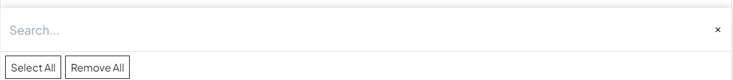
Core Mandatory Continuing Education
Midwifery-Specific Mandatory Continuing Education:
Specialized Areas:
Safety and Compliance Training:
Emerging Topics and Continuing Education:

IF Core Mandatory Continuing Education
Basic Life Support (BLS)
Advanced Cardiovascular Life Support (ACLS)
Neonatal Resuscitation Program (NRP)
Pediatric Advanced Life Support (PALS)
Infection Control and Prevention
Hand Hygiene and Aseptic Technique
Bloodborne Pathogens
Patient Safety and Risk Management
Workplace Safety (e.g., OSHA Compliance)
HIPAA (Health Insurance Portability and Accountability Act) Compliance – For U.S. healthcare workers
Ethics in Nursing and Midwifery
Cultural Competence and Sensitivity
Pain Management and Assessment
Medication Administration and Safety
Safe Patient Handling and Mobility
Sharps and Needlestick Injury Prevention
Basic and Advanced Wound Care
Communication and Interprofessional Collaboration
Legal Issues in Healthcare and Nursing
End-of-Life Care and Palliative Care
Health Informatics and Electronic Health Records (EHR)
Documentation and Legal Standards in Nursing
Confidentiality and Patient Privacy
Restraints and Seclusion
Substance Abuse and Impairment in Healthcare Professionals

IF Midwifery-Specific Mandatory Continuing Education:
Antenatal Care and Screening
Postpartum Hemorrhage Management
Fetal Monitoring and Interpretation and : remove Perineal suturing (not in this list)
Labor and Delivery Complications
Water Birth Safety and Guidelines
Maternal and Neonatal Resuscitation
Breastfeeding and Lactation Support
Management of High-Risk Pregnancies
Caesarean Section Assistance
Perinatal Mental Health
Preeclampsia and Eclampsia Management
Newborn Care (NICU Management, Special Care Nursery)
Intrapartum and Postpartum Care
Obstetric Emergencies
Contraception Counseling and Family Planning
Cultural Sensitivity in Maternity Care
Maternal Fetal Medicine (MFM) Updates

There is an issue:
When you select :
Antenatal Care and Screening
Postpartum Hemorrhage Management
Perineal suturing (which should’nt be on this list)

Then: When you unselect Midwifery-Specific Mandatory Continuing Education, the sub fields Antenatal Care and Screening and Postpartum Hemorrhage Management and Perineal suturing still remain:

IF Specialized Areas : this sub section field is missing
Emergency and Trauma Nursing
Critical Care Nursing (ICU/CCU)
Oncology Nursing
Pediatric Nursing
Mental Health Nursing
Geriatric Care and Nursing Home Care
Substance Abuse and Addiction Counseling
Chronic Disease Management (e.g., Diabetes, Hypertension)
Advanced Wound Care and Ostomy Management
Public Health and Community Nursing
Home Health and Hospice Care
Operating Room/Perioperative Nursing
Telehealth and Virtual Healthcare
Obstetric Anesthesia Management
LGBTQ+ Health and Care

IF Safety and Compliance Training: this sub section field is missing
Workplace Violence Prevention and Management
Aggressive Behavior Management (De-escalation Techniques)
Fire and Emergency Preparedness
Radiation Safety
Safe Use of Medical Devices and Equipment
Infectious Disease Control (including COVID-19 Protocols)

IF Emerging Topics and Continuing Education: this sub section field is missing
Telehealth and Digital Healthcare
Artificial Intelligence in Nursing Practice
Pandemic Response and Preparedness
Climate Change and Health Impacts
Trauma-Informed Care
Health Equity and Reducing Disparities
Mental Health First Aid
Gender-Affirming Care
Human Trafficking Awareness
Opioid Crisis and Pain Management Alternatives

Other Educations:

Upload Certificate: please fix the issue with the choose files design: the cross is on the wrong location, should be use below to remove the added files.


Please add et the end:

Experience:
After this sentence: Please add your full nursing work experience to strengthen your profile and get hired faster. Please keep update as your experience grows:
Please Add: Work Experience 1
Type of nurse and specialties should be the same falling tree system than in Profession and register nurse:
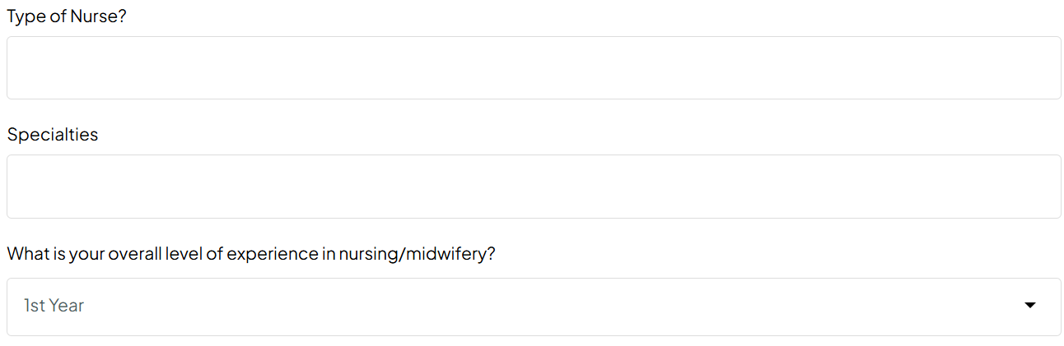
Please add:
What is your Level of experience in this specialty: (Missing)

Adults, Maternity OB/GYN/MFM, Paediatrics Neonatal Perinata,l Community: Should pop up only when selected, please use the same tree system than in Profession and register nurse:



Remove Previous Employers before Position Held

Employment Type:
Permanent:
Temporary:

If Permanent: selected:
Full-time
Part-time
Agency Nurse/Midwife
Freelance
Local
Volunteer

If Temporary: selected:
Temporary
Contract
Term Contract
Travel
Per Diem
Local
On-Call
PRN (Pro Re Nata)
Casual
Locum tenens (temporary substitute)
Agency Nurse/Midwife
Seasonal
Freelance
Internship
Apprenticeship
Residency
Volunteer
For each work experience : After Detailed Job Descriptions, please add those fields:
Areas of Expertise
Specific skills and competencies

Type of evidence
Upload evidence Choose file: For each work experience (Always possibility to delete the uploaded files)

+Add another work experience: button has to be placed at the end, after upload evidence and choose file.

Please add the possibility to delete added another work experience: For now you can just add but you can’t delete the added work experience.

When you +Add another work experience, then Update dynamically as the user adds work experience: Work Experience 2, Work Experience 3,…..

References:
When you +Add another Referee2, Referee 3, referee 4, after when you delete them back to referee1, after when you add another time, it is Referee 5 instead of Referee 2.

Vaccinations: See feedback 16 sent on the 30/10/2024
Work Clearances: I’m working on the content, I will send you soon
Professional Memberships:
Interview:
Personal Preferences:
Job Search & Personal Preferences:
Testimonial and Reviews:
Additional Information:

